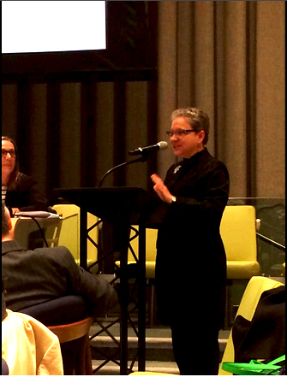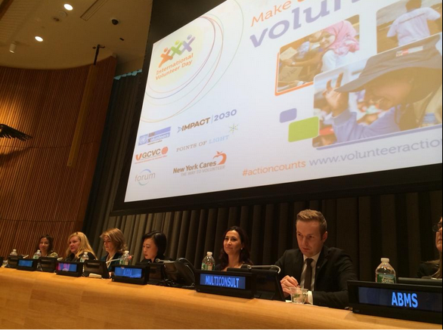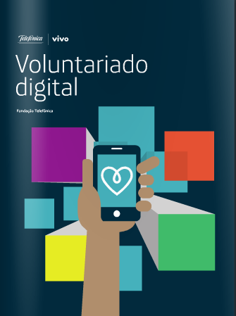

# **A Message from IAVE’s**

# **World President,**

# **Kylee Bates**

In This Issue

**News from IAVE**

* A Message from Our World President **(p.1)**
* Celebrating International Volunteer Day in New York **(p.3)**
* 500 Days, 500 Ways Features IAVE’s Agnetta **(p.4)**
* GCVC: Teaching, Learning, and Having Fun in Australia **(p.4)**
* Digital Volunteering **(p.5)**

**The Regional Challenge**

From Europe: EU Aid Volunteer Initiative **(p.5)**  
From Africa: Experts’ Meeting in Mauritius! **(p.5)**  
From Africa: Fire Safety in Nairobi, Kenya **(p.5)**  
From Asia-Pacific: Friendship Working Group is Ready to Launch! **(p.6)**  
From Asia-Pacific: Southern Taiwan Volunteer Sports Game **(p. 7)**  
From North America: National Volunteer Week 2015 Theme **(p.7)**  
From Arab Nations: Volunteering for The Oman Cancer Association **(p.8)**

**Dear Readers:** This month we undertake a major redesign of E-IAVE, thanks to the work of Jessica Han, our new Manager of Communications and Marketing.  We look forward to your reactions to our new look via email at [membership@iave.org](mailto:membership@iave.org).

November-December 2014

The resolution declaring the 5th of December International Volunteer Day (IVD) passed by the United Nations nearly 30 years ago aimed to “stimulate the work of volunteers” and give “encouragement to those volunteers, many of whom engage in volunteer service at considerable personal sacrifice”. As the 5th of December passed this year I found myself wondering whether International Volunteer Day was really anything other than just good public relations. I was confident that IAVE was taking its role seriously to ‘promote, strengthen and celebrate

**E-IAVE**

volunteering’. We were pushing forward on our global call to action to have volunteering recognized as a “*critically important strategic asset to be mobilized in support of the Post-215 Development Agenda and the Sustainable Development Goals”.* We were a key stakeholder and participant in the launch of *IMPACT2030 –* collaboration between the United Nations and the business sector to help achieve the UN Sustainable Development Goals by 2030 through corporate employee volunteering, and we presented the signatories to our Call to Action to the United Nations Secretary-General via letter on December 5th.

However I was curious as to whether for others whose passion, indeed obsession, may not be as strong, IVD was merely a brief moment of celebration for those who had done good works throughout the previous year. Or whether it did truly – as nations intended - continue to “stimulate the work of volunteers” and act as a catalyst for volunteering.

So I went searching. Through online news archives I learned that governments, non-government organizations and businesses around the world continue to celebrate the work of volunteers in countless ways, for example the creation of a volunteering logo in China, the launch of a volunteer card in Malaysia through which local businesses can reward a volunteer, or the release of research on volunteering in Australia conducted by the country’s leading employment site. I learned also that there was no shortage of ‘call to action’ activities taking place:

In **Kathmandu** the “Youth in Black Cap” campaign by volunteers and activists launched to coincide with IVD began with a silent protest that saw youths donning black caps as a symbol to inform communities about the increasing incidences of child sexual abuse and pressure lawmakers to implement child-friendly laws;

In **Kingston, Jamaica** the Jamaica National Building Society (JNBS) Foundation, the Council of Voluntary Social Services (CVSS) and CUSO International collaborated to host the second annual National Volunteer Symposium under the theme of ‘Volunteerism: A Spotlight on Youth Leadership and Innovation”;

In **Pakistan** the Punjab Education and Youth Minister announced that the government intends to collaborate with local and international organizations to start a program for peace volunteers and urged young people to become volunteers for peace;

In **Syria** a group of young people launched “To Keep Them Warm” a volunteer campaign to deliver clothes to displaced families at makeshift residential centers after fleeing their homes; and

In **Vietnam** – nearly 100 Vietnamese and foreign organizations joined the Vietnam Volunteer Festival which incorporated a blood donation drive, a program against domestic violence and a charity event for disadvantaged children.

In light of the above and the activities we heard IAVE were involved in to mark IVD, my curiosity has been satisfied. It would seem that the 5th of December does indeed do as the drafters of the IVD resolution intended and continues to “stimulate the work of volunteers” and “give encouragement to those volunteers.” May it always be so.

*On behalf of the IAVE Board of Directors and Secretariat I thank you for your engagement in and continued support for the work of IAVE. We have big aspirations that will only be achieved through our collective effort – or perhaps better said in the words our Volunteering New Zealand colleagues celebrated International Volunteer Day with* ***‘Ma tini ma mano ka rapa te whai* –** *By many, by thousands, the work will be accomplished.’”*

**Whether the approaching season is a sacred time for you, or you simply mark the turning of the calendar from one year to the next, I wish you all peace, goodwill and prosperity as you pursue your volunteering endeavors in 2015.**

Kathi Dennis, our executive director, and members of our Global Corporate Volunteer Council (GCVC) led the way for IAVE at a special program at the United Nations headquarters in New York City, organized by United Nations Volunteers.

Kathi quoted from a letter, signed by Kylee Bates, our World President, and herself that was being transmitted via UNV to the Secretary-General:

“Today, we are pleased to announce that over 600 leaders from the breadth of the global volunteer community, from global corporations and international NGOs to grassroots leaders and social entrepreneurs, have joined with us in advocating for this recognition of volunteering [as a strategic asset to achieve the Sustainable Development Goals].

“We urge the Member States, you and the leaders of all UN agencies and programs to respond positively to these recommendations.  As the Sustainable Development Goals are announced, we urge you to call on all people to commit their time, their skills and their energy as volunteers, working together, to achieve the SDGs and to challenge businesses, schools and universities, faith communities and community groups to mobilize their members as volunteers for this critically important work.”

The overall focus of the program was on how companies can focus their volunteer efforts on the SDGs.  This included announcement of Impact 2030, a new initiative to achieve that.  IAVE has been active in the development of this effort and three of our GCVC members – UPS, Ritz-Carlton and IBM – are among the founding companies.

Kathi also moderated a discussion with Marian Juste Picon from Telefonica and Jennifer Farrington from BD, both GCVC members and recipients of IAVE’s Global Corporate Volunteering Awards.  Marian spoke of the engagement of Telefonica volunteers in addressing child labor and other critical issues in Latin America and Jennifer described the work of BD volunteers in helping to rebuild heath care services in Haiti.

Celebrating International Volunteer Day at the United Nations

Since August 18, 2014, IAVE has partnered up with VSO, Australian Red Cross, AVI, CUSO, FK Norway, UN Volunteers, VSA, and World Teach to count down the last 500 days of the Millennium Development Goals with the 500 Days, 500 Ways online campaign. The campaign features a website, [500ways.org](http://www.500ways.org), that highlights volunteers and how their work supports sustainable development outlined in the Millennium Development Goals.

IAVE’s own Agnetta Nyalita, our youth representative from Kenya, has been featured on the 500 Days, 500 Ways website. [Click here](http://500ways.org/2014/09/21/advocating-for-of-youth-development-and-volunteerism/) to read about how Agnetta has been working to advocate youth volunteerism and development with IAVE.

**Want to share how you have been supporting the Millennium Development through volunteering?** **Send us your story to** [**Jessica@iave.org**](mailto:Jessica@iave.org) **and we will feature your story on 500 Days, 500 Ways!**

**GCVC: Teaching, Learning, and Having Fun in Australia**

**Sarah Hayes,** Consultant Director, IAVE’s Global Corporate Volunteer Council

The IAVE World Volunteer Conference in Australia was a very special time for all attendees – and that certainly includes many members of IAVE’s Global Corporate Volunteer Council. Attending the GCVC meeting prior to the opening of the conference were representatives from UPS, Amway, Google, EDP, Pimco, HSBC, Samsung, Adobe, Intuit, Northrup Grumman, RBC (Royal Bank of Canada) and UBM (United Business Media.) This meeting was particularly pivotal as it marked the first meeting where Ed Martinez, the President of the UPS Foundation and IAVE’s new corporate board member, served as the GCVC Chair. Mr. Martinez’ vision for the GCVC is an ambitious and thought-provoking one, and includes much more interconnected relations between GCVC and other initiatives in IAVE.

The meeting, held at Bond University, began with lunch with IAVE Board Members, and a tour of the amazing collection of Aboriginal art housed within the university .It continued with an enlightening – and amusing – history of corporate volunteering over the past thirty years given by Jeff Hoffman, CEO of Jeff Hoffman & Associates, and former head of Disney’s global community efforts. Attendees also heard from IAVE’s new World President, Kylee Bates, and a presentation by Kenn Allen and Ed Martinez on the progress of the Disaster Research Working Group. All

attendees agreed that they felt a much stronger connection to how GCVC fits into IAVE’s overall work because of these presentations and discussions.

The theme for the meeting was Corporate Volunteering as it relates to Professional Development – and not just employees, but the EVP Managers as well. GCVC colleagues were treated to interesting stories of the circuitous paths that brought each of our representatives to the role they now occupy. Many new ideas were shared, and the discussion was inspiring and intimate. GCVC members left the meeting with deeper relationships one with another and new nuggets of wisdom to take home and utilize in their work.

A number of GCVC representatives went on to the conference as forum and workshop presenters – on topics such as Turning Research into Action, Social Innovation in Corporate Volunteering and Fostering Sustainable Partnerships through Corporate Volunteering.

Thank you to the GCVC members who were able to bring their wealth of experience, knowledge and enthusiasm to both the GCVC meeting and the World Volunteer Conference!

IAVE Members on

500 Days,

500 Ways

**FROM EUROPE**

**EU Aid Volunteers Initiative**By **Dr. Eugen Baldas**, Head, German Caritas Association’s Volunteer Sector, IAVE Vice President, & IAVE Regional Representative (Europe)

The number of natural and man-made disasters in the world has significantly increased in recent years and this trend is likely to continue. Humanitarian organizations need well-prepared and trained people to help communities struck by crises.

Many Europeans are eager to give their practical help where it is most needed, and the EU Aid Volunteers initiative will give them the opportunity to do so. This initiative brings together volunteers and organizations from different countries, providing practical support and establishing European standards on volunteering and benefit local organizations with capacity-building measures. It complements existing volunteer schemes in Europe, many of which have a national focus.

**The Regional Challenge**

**Back in March, IAVE’s Regional Representatives were given a challenge to provide our members an article from each of their regions for our monthly E-IAVE newsletters. This month we have several articles from members throughout the globe, including stories from those who celebrated International Volunteer Day on December 5th.**

**Digital  
Volunteering**

**Digital Volunteering** is a new book sponsored by Telefónica Vivo Foundation in Brazil, written by IAVE’s senior researcher Monica Galiano. The publication focuses on a study that examines the different ways in which technology impacts our lives.

Monica’s book outlines the different ways technology has molded our personal and social values, creating a sense of solidarity within the volunteer community. She takes into consideration the history between volunteerism and the Internet, starting from the Virtual Volunteering Project founded in the 70s. The book revisits stories of engagement between these volunteer leaders and how each culture approached digital communication in their own unique ways. Monica offers examples on how digital development has transformed communities throughout the globe, and how technology has creatively provided people with the resources they need.

IAVE has been supporting the work since 2012, at the 22nd World Conference in London. The idea was formed during this time at a round table discussion on digital volunteering. The participants included Sam Johnson (Volunteer Army, New Zealand), Ángel Solá (Cibervoluntarios, Spain), Eileen Sweeny (then Motorola Foundation director) and Raaida Mannaa (IAVE´s Global Youth Initiative). The round table discussed optimal ways to use technology to mobilize people to volunteer, and methods on how to jump the digital gap.

The book also highlights volunteering and social activism, Cyberactivism, Hacktivism, online volunteering, Wirearchy, cloud computing, InfoMutation, Redarchy, among other interesting topics related to digital communications today.

The publication was launched recently on Dec. 2nd, 2014 in São Paulo, Brazil during a presentation with Beth Kanter, blogger and writer, and Lorrana Scarpione, founder of [Bliive](http://www.bliive.com).

*You can download the PDF of the Spanish version at* [*Telefonica Viva Foundation*](http://bit.ly/Voluntariado_Digital_PORT) *or at* [*Issuu*](http://bit.ly/VoluntariadoDigital-BOOK)*. An English version is being prepared and will soon be released.*

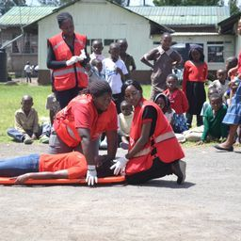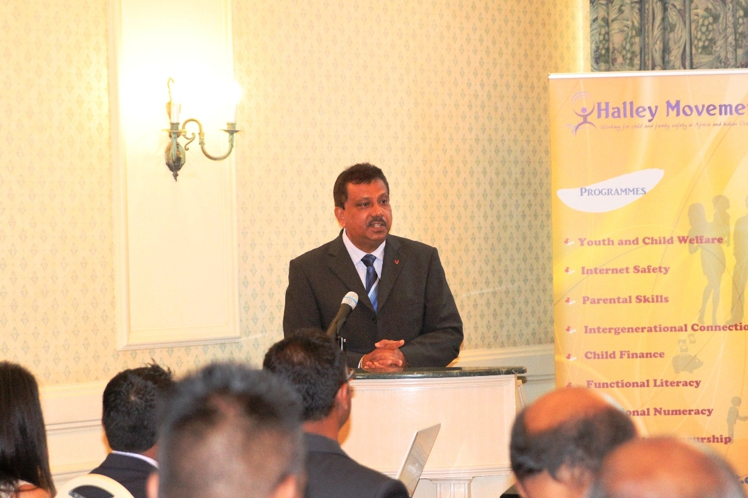

**International Volunteers Day Celebrations in Kenya  
B**y **Dr. Tuesday Gichuki**, Director, Africa Peace Service Corps, & IAVE National Representative for Kenya

2014 IVD was celebrated in Nairobi by 21 International and National Volunteer organizations under the auspices of Volunteer Involving Organizations Network at Mukuru Kwa Ruben Centre of HOPE. The center is located within Mukuru Kwa Ruben Slum in Nairobi.

The Ruben Slum (also known as the Mukuru community) was born in Nairobi’s

**FROM AFRICA**

**Experts’ Meeting on the theme: Redefining Child Welfare:** The Future Beyond 2015, Port Louis, Mauritius  
By **Mahendranath Busgopaul**, Secretary General, Halley Movement in Mauritius, & IAVE National Representative for Mauritius

An Experts Meeting was organized on Tuesday 21st October 2014 at Le Labourdonnais Waterfront Hotel, Mauritius on the theme: **Redefining Child Welfare: The Future Beyond 2015.**

The purpose of the meeting was to analyze and reflect on the issues of child welfare and parenting in Mauritius since the past decades and pave the way for future actions through the publication of a Blue Print.

At the official launching ceremony, the Minister of Gender Equality and Child Development reiterated the support of the government of Mauritius for NGOs’ towards their excellent work for child development and protection. The Program Manager of Parenting in Africa Network, Ms. Esther Okoth who also spoke at the opening event emphasized on the importance of promoting safer parenting in the African region.

Thirty-five (35) state and non- state actors involved in child welfare in Mauritius participated in the Experts’ meeting and the Core themes included:

* Youths & Child Welfare Issues-History and emerging partners
* Child development & Protection systems in the Republic
* Internet Safety and web oriented programmes for youngsters
* Parental skills programmes leading to healthy child development
* Intergenerational approach for child welfare in rural & difficult to reach regions

The blueprint is scheduled to be released by the end of January 2015.

In 2011 the European Commission's Humanitarian Aid and Civil Protection department (ECHO) has launched a number of pilot projects with more than 200 volunteers to gain real experience during the preparation of the EU Aid Volunteers initiative, a programme which will run from 2014 to 2020. There are studies and reviews from the pilot part.

More than 18 000 citizens are expected to take part in the program, contributing to humanitarian work and expressing their solidarity by helping people caught up in crises. An Information and Networking Day will take place on 23rd January 2015 in Brussels (+webstreaming).   
Further information: <http://ec.europa.eu/echo/en/what/humanitarian-aid/eu-aid-volunteers>

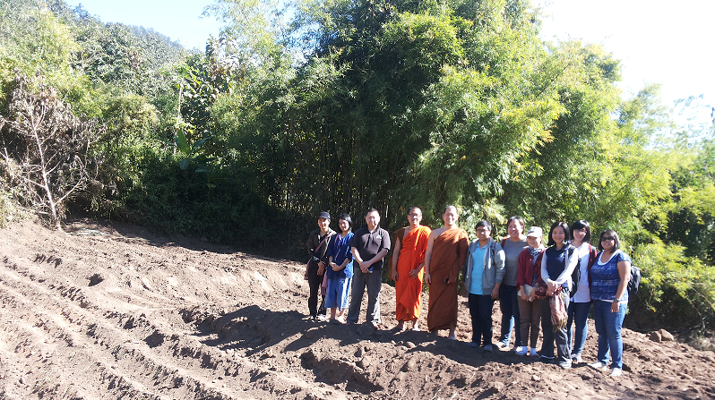

**FROM ASIA**

**Friendship Working Group is Ready to Launch!**By **Debbie Huang**, Secretary General, IAVE Taiwan

Based on Changwon Agreement (SEEDS) made during the 13th IAVE Asia Pacific Regional Conference in 2011, IAVE NRs reached consensus on strengthening the communication and collaboration with each other in Asia Pacific Region. The agreement has been kept in mind since then. In 23rd IAVE World Volunteer Conference & Youth Conference in Australia, the joining organizations from Macao, Vietnam and Taiwan, gathered again for further discussion of the very first collaborative project which is going to be carried out in 2015. The main idea is that volunteers from these counterparts could work together to promote the intellectual and emotional communications across the AP countries.

Association of Volunteers Social Service Macao (AVSM) initiated the first project. After their visit to Doi Pha Som (Doi Pha Mountain) in Northern Thailand, AVSM suggested that the equipment, hygienic condition, and water supply system in the village should be improved. In order to renovate their infrastructure in Doi Pha Som village and to understand local needs, three of the NRs, Phra Win (Volunteer Spirit Network), Leo (AVSM), and Debbie Huang (IAVE Taiwan) set out for site inspection and detailed discussion on December 1, 2014. It is sure that volunteers from Macau, Thailand, Vietnam, and Taiwan will start out their journey next year.

Hopefully, with this project, we could demonstrate a new model for regional cooperation, and maintain a long-standing friendship between IAVE networks.

Industrial district approximately 35 years ago when people began to build makeshift homes near the factories they worked in. The area now has a population of over 600,000 and many families live in corrugated iron shacks measuring 10 x 10 feet.

Many of the slum dwellers in Mukuru work as casual laborers in the manufacturing industries situated close to the slum, while others operate small-scale businesses selling vegetables and fruit or hawking various items. Earnings are low and often inadequate to feed their families. Consequently, their children look to other means of survival such as prostitution, drug peddling, begging, and criminal activities.

Among the major challenges in the slum areas of Nairobi are the frequent fire outbreaks that cause loss of life and property. The Nairobi City Fire Department is not able to manage the fires due to the unplanned structures devoid of access roads, which the firemen could use to deal with the outbreaks.

Community members, members of VIO Network, Local administrators, Senior Government officials, and local young people, attended the event at Mukuru Slums. The Chief Guest was the Australian Ambassador to Kenya, assisted by the Principal Secretary, Ministry of Labor, Government of Kenya.

The main focus of the event was sensitizing the community on fire safety through demonstrations by Nairobi City Fire Service. The participants also planted trees at the venue as part of the network’s environmental conservation initiative. Volunteer Involving Organizations Network was recently registered as a Society and is deeply involved in development of the National Volunteer Policy in Kenya. The Policy is in its final stages before presentation to Parliament. The Ministry of Labor has undertaken to have the policy and the Act of Parliament putting it into effect by February 2015.

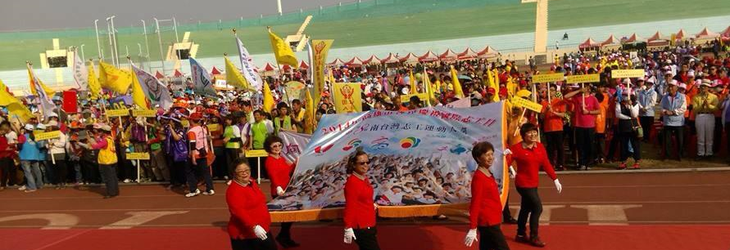

**FROM NORTH AMERICA**

**National Volunteer Week 2015 Theme**By **Volunteer Canada,** National Representative for Canada

April 12-18, 2015 is [National Volunteer Week](http://volunteer.ca/nvw2015" \t "_blank). It is also the 12th consecutive year that Volunteer Canada delivers the National Volunteer Week (NVW) campaign in partnership with [Investors Group](http://www.investorsgroup.com/en/default.aspx" \t "_blank).

A volunteer action is like a stone thrown in a lake: its effect has a direct impact. At the same time, like ripples, volunteer efforts reach out far and wide to improve communities. Undeniably, volunteers rock.

Findings from Volunteer Canada and Investors Group’s *[2013 Volunteer Recognition Study](http://volunteer.ca/content/2013-volunteer-recognition-study" \t "_blank)* indicated that many volunteers appreciate a genuine thank you. Whether it is with words highlighting the impact of a volunteers’ contribution or a small personalized token, a custom and sincere thanks makes a difference.

To collectively celebrate Canada’s 13.3 million volunteers, the NVW 2015 *“Volunteers are part of the ripple effect,”* campaign will feature stones available at Volunteer Canada’s online gift store. Canadians are urged to recognize volunteers by offering them a token stone. Each stone will feature an engraved message on one side: *Volunteers Rock.*

Just like no two stones are identical, every volunteer is unique. This is why one side of the stone is blank for you to write on. A name, an impact word or a short thank you can be added to personally recognize a volunteer.

[Stay tuned](http://bit.ly/1vsYnJS" \t "_blank) for more information about the NVW 2015 campaign.

**IVD Celebrations in Taiwan**

By **Debbie Huang**, Secretary General, IAVE Taiwan

Since 1985, December 5th has been the declared International Volunteer Day (IVD) by the United Nations. According to the analytics published by the Ministry of Health and Welfare in Taiwan, there are more than 1 million people who have their own voluntary service record book, and the total time spent volunteering had reached 99 million hours before the end of 2013. It is said that volunteerism should be highly valued, for volunteers are not only an important asset of the society, but also a progressive force for societal harmony and national development in this era.

Praising outstanding volunteers across the country is a big event annually during IVD. For past decades, the national and local governments hold celebrative activities on IVD to recognize volunteers’ effort. This year, Taipei city government added a section of corporate volunteers to praise 18 enterprises and corporations for their volunteering efforts. Many of the corporate volunteers implemented different programs for their companies. One corporation implemented a ‘Corporate Volunteer Day’, encouraging their employees to do volunteer work in office hours. Another aided those who are physically or mentally challenged to join the workforce.

One company adopted a park to maintain, and another collected and donated food to elders and disadvantaged families. All of them fulfill their social responsibility and make Taipei City a better place.

Kaohsiung city government decided to hold Southern Taiwan Volunteer Sports Game. Li, Yong-De, deputy mayor of Kaohsiung, said ’Government has its limit, but the society has infinite power.’ Volunteers play a vital part on municipal works as well as civil society. Volunteers not only the guardians of the community, but the catalysts to reach out to the world.”  Numerous celebrative activities took place in 20 counties and cities across Taiwan to show their gratitude for the contribution of volunteers. Friendly Chen, the newly elected President of IAVE Taiwan said ‘by promoting IVD, more and more citizens will join volunteering work, and therefore, lead to a peaceful society. Hopefully, the vision of ‘volunteering Taiwan’ could be realized.’

**FROM THE ARAB NATIONS**

**Volunteering for The Oman Cancer Association**By **Dr. Patricia Nabti**, Founder and Director, The Association for Volunteer Services, & IAVE Regional Representative (Arab Nations)

The Oman Cancer Association was founded in 2002 and officially registered in May 2004. It started as an initiative of a cancer survivor, Mrs. Yuthar Al-Rawahi.

The main objective of the Association since its inception is to advocate for cancer awareness, that:

***Repeated, regular examination leads to early diagnosis that leads to better prognosis and high probability of complete cure.***

OCA works to advocate for awareness and to educate Omani communities on the risks and hazards of the disease, to educate the patients and empower them with regard to their condition, and to support both the health care providers who tirelessly work with cancer patients and the researchers who are trying to identify cancer’s causes and future treatment. OCA also engages in capacity building, specifically in the development of cancer councilors and advocates.

In addition, OCA conducts an important screening program through its Mobile Mammography Unit which has performed more than 11,000 mammograms since November 2009. In January 2011, the Association also opened ***Dar Al Hannan,*** which caters to children with cancer under the age of 15 years who live outside the Governorate of Muscat and who require further out patient treatment. It provides free accommodation and boarding for up to 16 families at a time and a shuttle service to and from the hospital.

**Relevance of volunteers to the project**

Aside from the administrative team of secretaries, drivers, and Dar Al Hanan nurses, everyone who “works” with OCA does so on a volunteer basis. OCA’s volunteers fall into three broad categories: doctors, service providers, and regular volunteers. OCA has doctors who volunteer a few hours a month year-round to provide free clinical breast exams at the headquarters and radiographers who volunteer their evenings a couple of times a week to study the MMU images.

Service providers include graphic designers, photographers, or social media specialists who get involved with OCA on an as-needed basis, in particular for the Annual Walkathon.

And there are regular volunteers, both cancer survivors and those not impacted directly or indirectly by the disease – high school and college students, professionals with full-time jobs, and housewives. These are locals as well as expatriates who man OCA’s tables for the October campaign or other ad hoc advocacy events, register people for OCA’s Annual Walkathon, and provide extra-hands that allow for our Hug-A-Bear initiative. Volunteers also read to and play with the children at Dar AlHanan, organize toy-drives, and otherwise upgrade Dar AlHanan from an accommodation to a “Home Away from Home".

The list goes on and on. The relevance of volunteers to OCA is vital – while the President and Board (all unpaid, hence volunteer, positions) are the engine of the operation, the other volunteers are the fuel that make it run. The quality of volunteers clearly determines the efficiency and effectiveness of the organization as a whole.